**CMPS350 Project – Mizān - Phase 1**

Project Documentation and Testing Screenshots

Ahya AlWattar   202204901

Bsmalla Mostafa   202204404

Carmela Chavez   202206774

Ganna Soltan      202205763

April 13, 2025

Contents

Grading Rubric 3

Application Design 4

Entities Class diagram 4

Entities Repositories and Services Class Diagram 6

API Endpoints 7

UI Sketches and Design: 8

Testing 13

Login - Student 13

Dashboard 14

(Navigation Menu for a student) 14

Current Courses view (available to all users) 15

Single course (details) view 15

Assessments of a single course 16

Comments of a course 16

Add comment 17

Replying to a comment 17

Get Assessments (here, it’s for a student) 18

Filtering assessments by course(s) 18

Filtering assessments by semester 19

Courses Workload Summary Report (for a student) 20

Student Assessment Calendar 21

Login – Instructor ( Navigation Menu) 22

Course page when signed in as instructor (all courses they’re teaching) 23

Assessments through course page; can add, update and delete them 23

Instructor updating assessment 24

Instructor adding assessment 24

Instructor deleting assessment 25

Assessments page from instructor login; can add, update and delete from it; can also filter assessments 25

Login – Coordinator (Navigation Menu) 26

Courses page for Coordinator; all courses in coordinator’s department 26

Shows assessments for specific course 27

Shows all assessments, can filter by course & semester 27

Course workload summary report for all courses in a Coordinator’s program 28

# Grading Rubric

|  |  |  |  |  |
| --- | --- | --- | --- | --- |
| Criteria | | % | Functionality* | Quality of the implementation |
| 1. Application Design: Class Diagram showing Entities, Repositories and Services | | 8% | Done (100%) |  |
| **2) Design and implement** | | **87%** |  | + Outstanding work. Best submission  + Fiter by course  + NO need for cancel  - Huge 1339 lines globals.css file! CSS should also be modular. CSS only needed for certain components/pages should be co-located with in the same subfolder (e.g., Calendar related CSS could have been co-located in the same folder as the Calendar component).  - Better to place the data folder outside the app folder to keep the app folder for UI/Business logic only.  - getAllUsers could be renamed to simply getUsers  - User.name should be split into firstName and lastName  - Better to use a meaningful name for the role: Student, Instructor, Coordinator.  - Better to make the ids integers rather than String.  - No need to use classes such as User class.  - getUsers and getUserByEmail could be private methods.  - LoginCard could be renamed LoginForm. It could be a Server component rather than a client component.  - No need for Dashboard with hardcoded data. After login redirect the user to the **/assessments** page.  - Avoid + to concatenate strings and use String template instead  - No need to put all routes under home  - For getSections(user, semId) do one return statement. See the model solution.  - assessment id could be a numeric value. No need for phase property.  - Comment id could be a numeric value. CommenterId could be authorId. parentCommentId could be replyToCommentId. see model solution.  - Unnecessary code in the CommentRepo such as      this.courseFilePath = path.join(process.cwd(), "data/courses.json");      this.userFilePath = path.join(process.cwd(), "data/users.json");  - Rename semId to semesterId  - Assessment Repo some unneeded code such as  this.sectionFilePath = path.join(process.cwd(), "data/sections.json");  this.userFilePath = path.join(process.cwd(), "data/users.json");  - deleteAssessment unnecessarily complex. See model solution.  - Assessment Validation can be simpler. See model solution.  - AssessmentList could be more modular by creating an AssessmentCard  - Poor css such could be a class #tags see base solution  - UpsertAssessmentForm.jsx could simply be AssessmentForm.jsx  - Assessment Type hard-coded and project phase complicated  - No need for cancel button in the forms unless it is a dialog box  - type should be before the title in the assessment form  - Lucide react is a better icon library allowing the download and use in individual ones without adding a whole online dependency of bootstrap icons.  - For css avoid id styles and favor classes.  - For charts you can use the React wrapper of charts.js. See the model solution. |
|  | **Login and Main navigation** | 6 | Working (100%) |  |
|  | **Image result for add task icon Add Assessment** | 15 | Working (100%) |  |
| **https://cdn1.iconfinder.com/data/icons/MetroStation-PNG/128/MB__tasks.png Update Assessment** | 10 | Working (100%) |  |
| **Image result for delete task icon Delete Assessment** | 5 | Working (100%) |  |
| **Related image Get Assessments** | 15 | Working (100%) |  |
| **Image result for tasks calendar icon Student Assessments Calendar** | 10 | Working (100%) |  |
| **Related image Add Course Comment** | 8 | Working (100%) |  |
| **Related imageGet Course Comments** | 8 | Working (100%) |  |
| Image result for Report icon**Courses Workload Summary Report** | 10 | Working (100%) |  |
| **3) Testing documentation** using screen shots illustrating the app testing.  - Discussion of the project contribution of each team member [-10pts if not done] | | 5% | Done (100%) |  |
| **Total** | | 100 | 96 | Outstanding submission. Except some parts are unnecessary complex. Also, modularity should be improved. See the model solution. |
| Copying and/or plagiarism or not being able to explain or answer questions about the implementation | | -  100 |  |  |

# Application Design

## Entities Class diagram

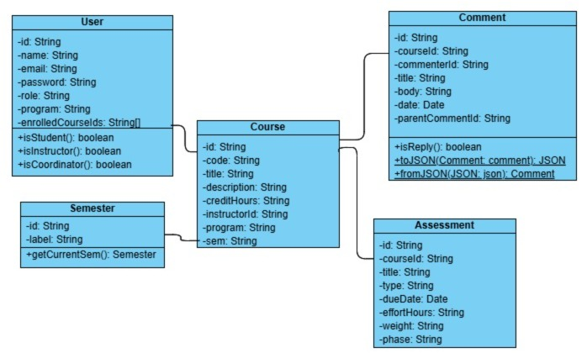

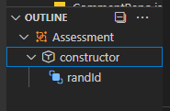

## A screenshot of a computer AI-generated content may be incorrect.A screenshot of a computer AI-generated content may be incorrect.A screenshot of a computer program AI-generated content may be incorrect.A screenshot of a computer AI-generated content may be incorrect.Entities Repositories and Services Class Diagram

# API Endpoints

We used the following endpoints:

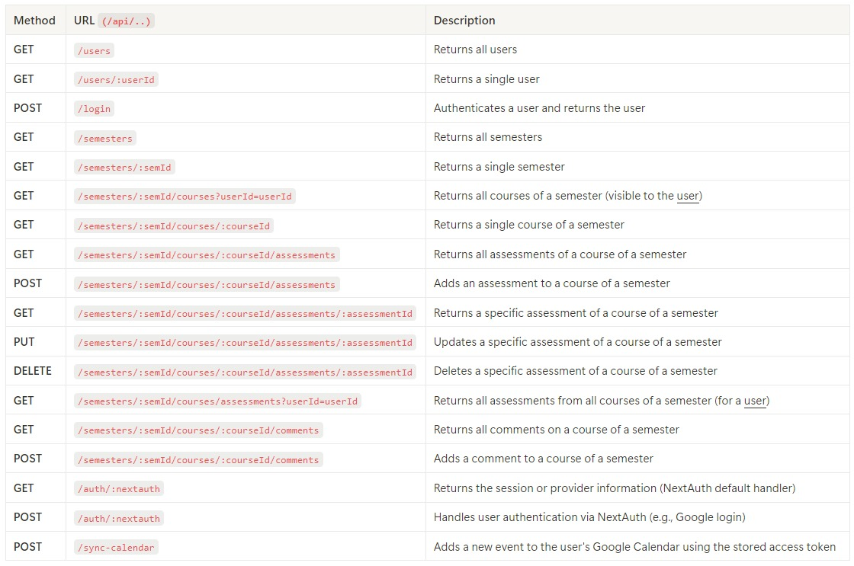

# UI Sketches and Design:

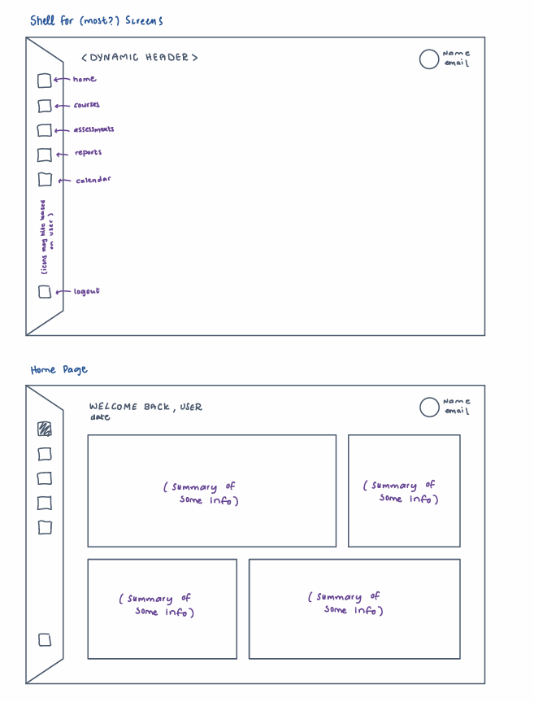

# Testing

Login - Student  
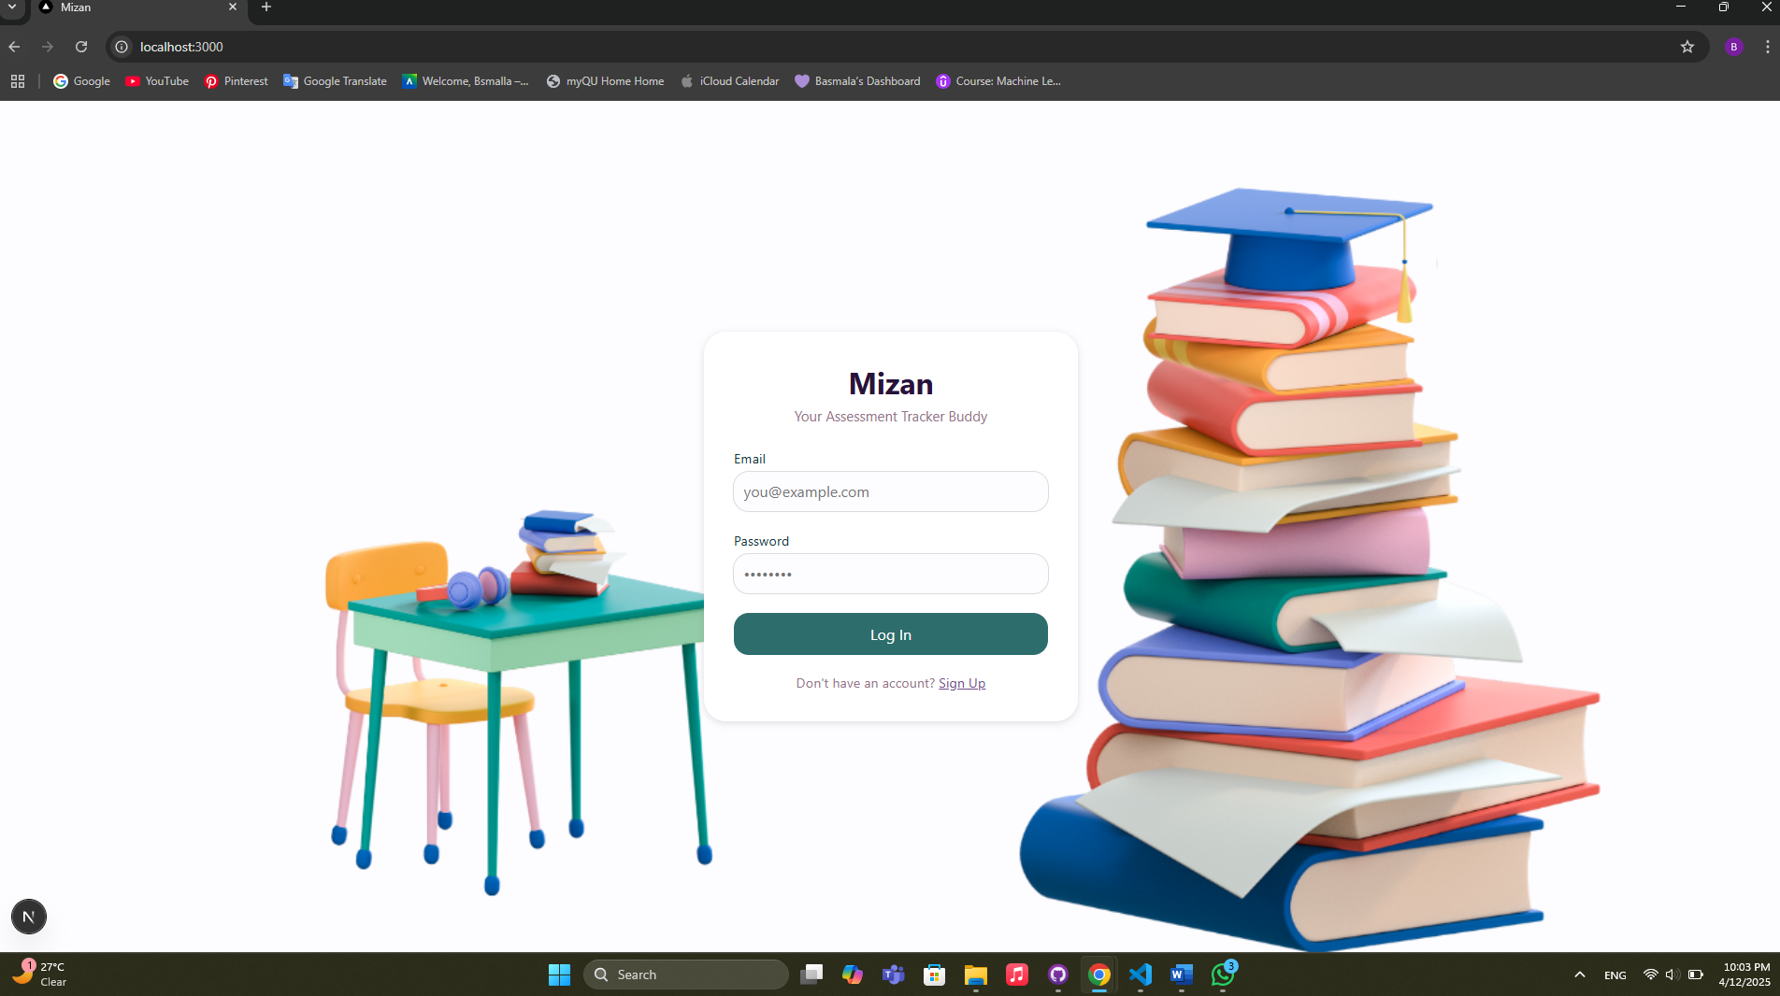

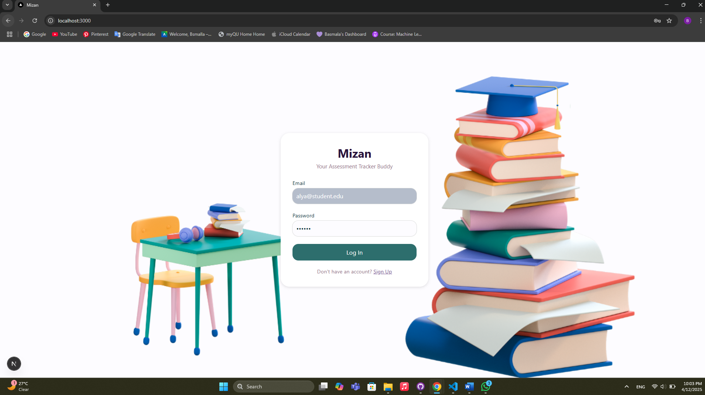

### Dashboard

### (Navigation Menu for a student)

### Current Courses view (available to all users)

### Single course (details) view

### Assessments of a single course

### Comments of a course

### Add comment

### Replying to a comment

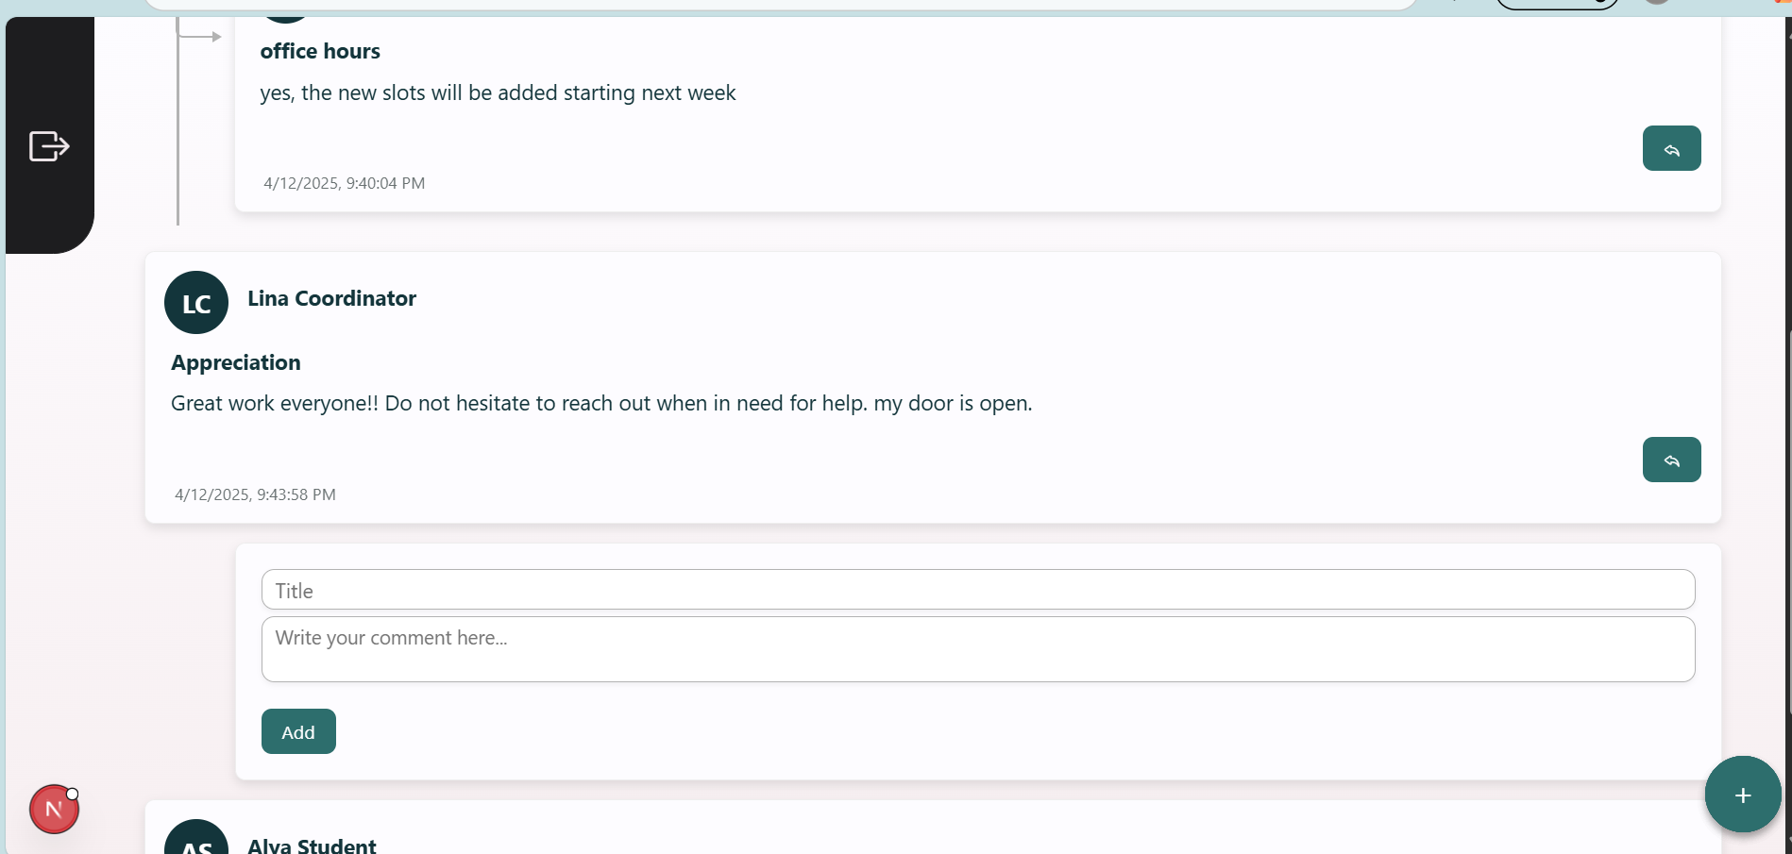

## Get Assessments (here, it’s for a student)

### Filtering assessments by course(s)

### Filtering assessments by semester

### Courses Workload Summary Report (for a student)

### Student Assessment Calendar

#### Signed in to Google to sync

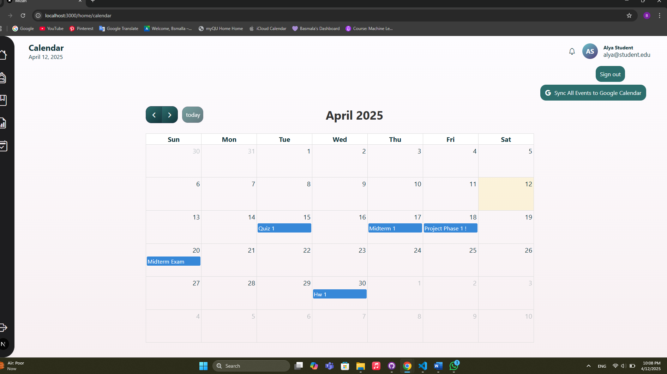

#### Sync with Google Calendar

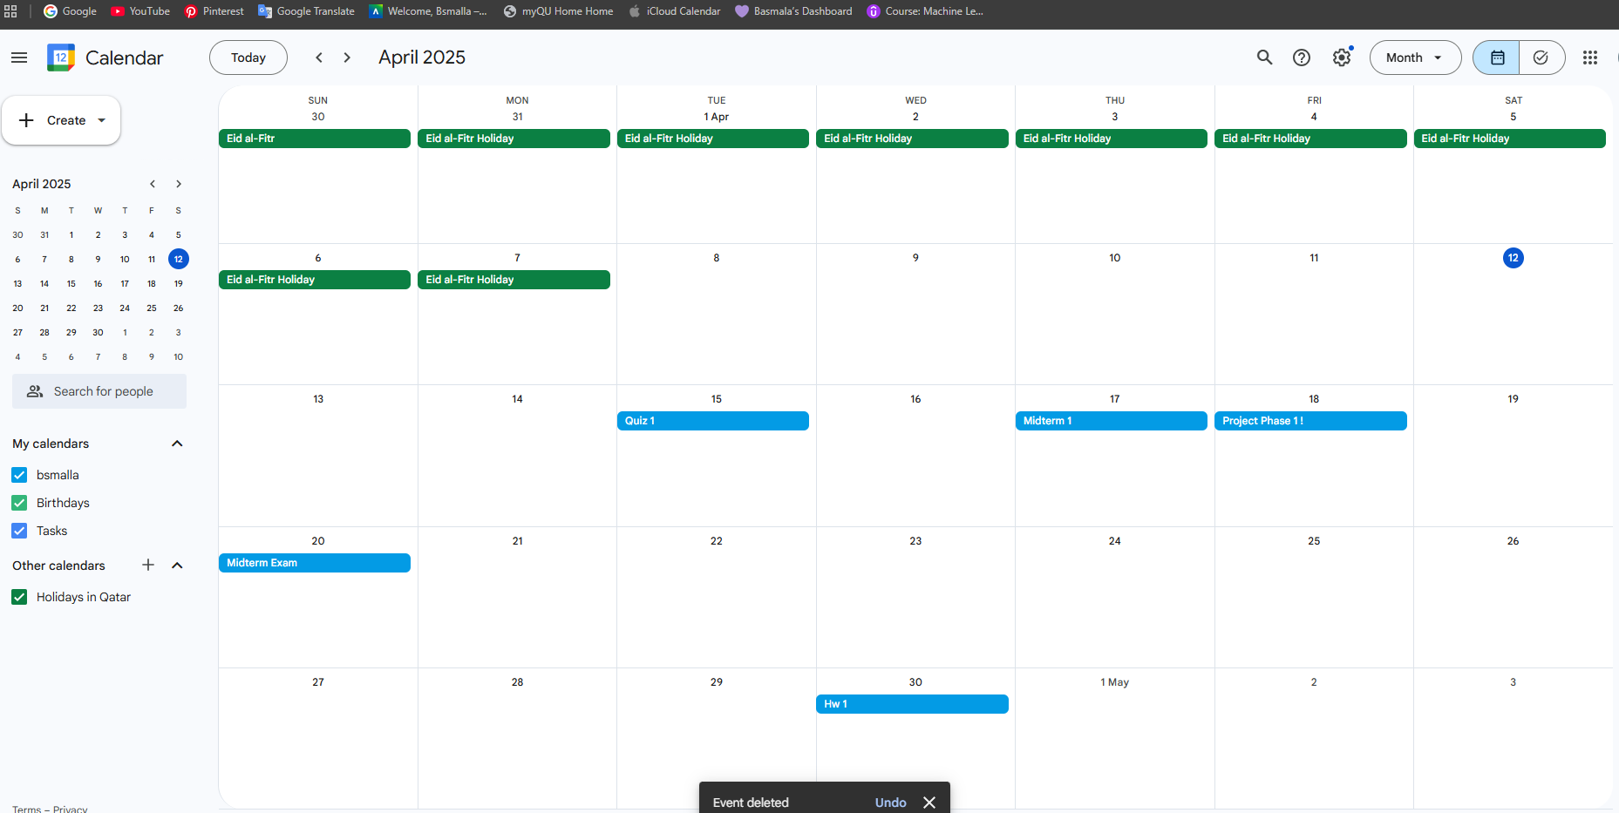

## Login – Instructor ( Navigation Menu)

## Course page when signed in as instructor (all courses they’re teaching)

## Assessments through course page; can add, update and delete them

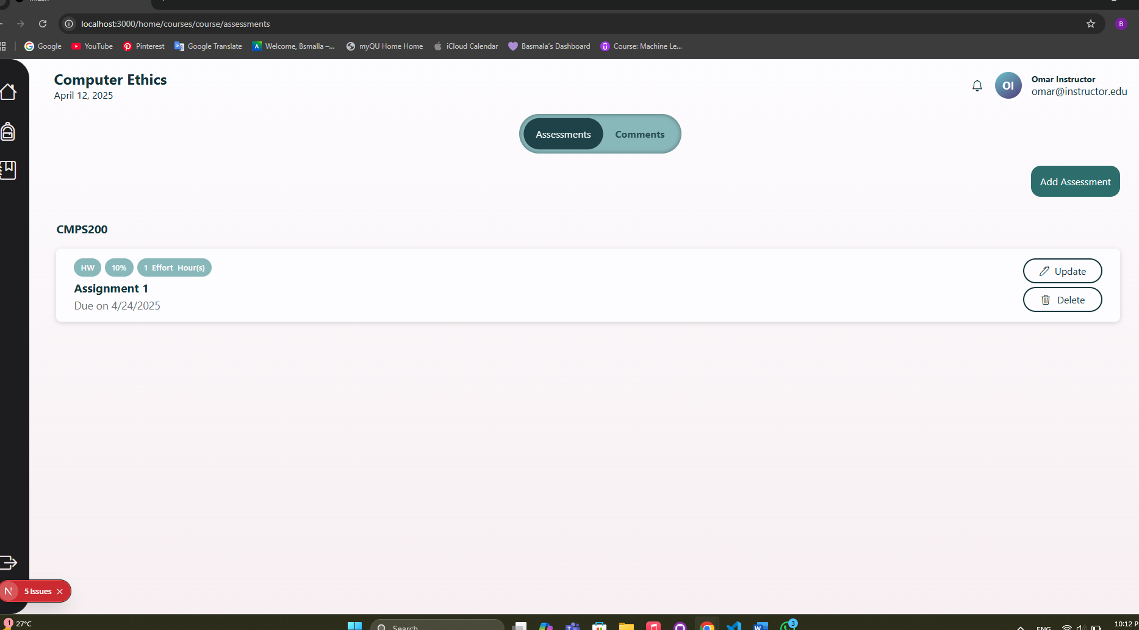

### Instructor updating assessment

### Instructor adding assessment

### Instructor deleting assessment

## Assessments page from instructor login; can add, update and delete from it; can also filter assessments

## Login – Coordinator (Navigation Menu)

## Courses page for Coordinator; all courses in coordinator’s department

### Shows assessments for specific course

## Shows all assessments, can filter by course & semester

### Course workload summary report for all courses in a Coordinator’s program

